2019 Stx Tune-Up
St Croix Yacht Club
Teague Bay, St Croix USVI
February 24th, 2019

SAILING INSTRUCTIONS

1 RULES

The regatta will be governed by the rules as defined in the current The Racing Rules of Sailing.
  - Personal Flotation Devices (PFD) shall be worn by any sailor under the age of 16, at all times while on the water except for brief periods while adjusting personal gear.
  - Once the warning signal has sounded, Safety Officers and /or parents must clear the area and may not coach, handle lines, drive, or call tactics.

2 ENTRIES

2.1 Competitors may Register by completing the entry form online at www.stcroixyc.com, paying the entry fee.
2.2 Registration ends February 23rd at 1800.
2.3 Entry fees will be collected not later than the Competitors Meeting on February 24th.

3 NOTICES TO COMPETITORS

3.1 Notices to competitors will be posted on the official notice board located at west side of clubhouse, facing the tee dock.

4 SIGNALS MADE ASHORE

4.1 Signals made ashore will be displayed from the flagpole on the east lawn. If a postponement is signaled ashore, the warning signal will be made not less than 30 minutes after flag AP is lowered.

5 SCHEDULE OF RACES and CLASS FLAG(S)

5.1 Friday, February 22nd
1800-2000: Registration at SCYC Happy Hour. Via Laptop.
Sunday, February 24
1200: Competitors Meeting
1300: Warning signal for first class
1700: Deadline for last start
Awards Presentation, As soon as possible after the Race Committee hits the dock

5.2 The class flags are:
Multihulls Purple
Jib/Main Green
Spin. Racing White
Rhodes 19 Pink
Optimist Green Fleet Green

6 RACING AREA

6.1 The racing area will be Teague Bay and the Buck Island Channel.
6.2 The Optimist Green Fleet will sail on a different Course and area.

7 COURSE[S] and MARKS

7.1 All marks will be orange or yellow buoys.
7.2 Attachment A shows the courses, course designations, and the marks in order. All marks are rounded to port, with the exception of the leeward gate.
7.3 Attachment B shows the courses to be sailed by the Optimist Green Class

8 STARTING AND FINISHING LINES; STARTING SYSTEM

8.1 The starting line will be between an orange flag on the R/C signal boat and a nearby mark off the Port Side of the R/C Boat.
8.2 The finish line will be between a blue flag on the R/C signal boat and a nearby mark off the Starboard side of the R/C Boat.
8.3 The start system will be a “5 Min” Start sequence for every class except Optimist Green Fleet. Optimist Green will use a “3 Min” Start Sequence.
8.4 For Multi Class starts the R/C will use a Rolling Sequence.
8.5 The first class to start the day, will be announced at the Competitors Meeting.

9 PENALTY SYSTEM

9.1 For all classes, rule 44.1 is changed so that the Two-Turns Penalty is replaced by the One-Turn
Penalty

10 TIME LIMIT

10.1 A boat starting more than 5 minutes after her starting signal will be scored DNS without a hearing. This changes rule A4.
10.2 A race may be abandoned by the race committee, if the leading boat has not rounded the first mark within 20 minutes of starting, or the time for first boat to finish exceeds 40 minutes from start. This modifies rule 32.
10.3 Boats failing to finish within 40 minutes after the first boat in their fleet finishes will be scored one (1) point more than the number of finishing boats and will be scored TLE. This changes rules 35, A4.1, A4.2, A5, and A1.

11 PROTESTS and REQUESTS FOR REDRESS

11.1 A boat intending to protest shall inform the signal boat, on the finish side, as soon as they finish.
11.2 Protests shall be delivered to the Protest Secretary at the clubhouse east room.
11.3 Protests will be heard in the protest tent; all protests will be heard openly.

12 SCORING

12.1 If at least 5 races are completed, each boat's worst score will be excluded from her series score.
12.2 One race constitutes a series.
12.3 Low Point Scoring System, appendix A will apply
12.4 CSA rating system for all classes except one design classes

13 PRIZES

13.1 The Top Finisher in each class will get an award, except Green Fleet, where the Top three will get prizes and everyone will be recognized

14 COMMUNICATION.

14.1 SCYC and R/C will monitor VHF Channel 6

15 RETIRING FROM RACING

15.1 Any sailor retiring from a race or for the day, please contact the R/C or the SCYC asap when reaching shore.

16 GREEN FLEET WEATHER
-Green Fleet will not sail with gusts of winds above 17kts.
-If winds exceed 17kts, Green Fleet Sailors will be able to attend on shore training, with possible sailing by the T-Dock.

17 DISCLAIMER OF LIABILITY

Competitors participate in the regatta entirely at their own risk. See Rule 4, Decision to Race. The organizing authority will not accept liability for material damage or personal injury or death sustained in conjunction with or prior to, during, or after the regatta.

ATTACHMENT A

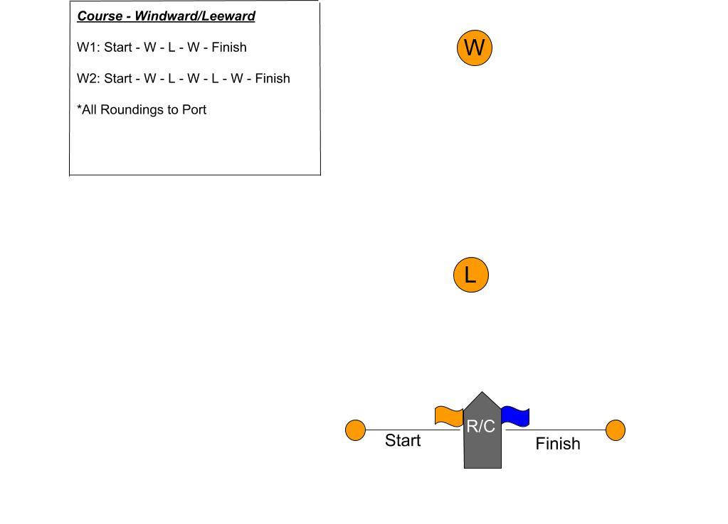
ATTACHMENT B

